Computer Network HW2 黃偉棟 01057162 聶竣朗 01057160

1.

| Nonproprietary Internet Apps | Application-layer protocols |
| --- | --- |
| E-mail | SMTP |
| Remote Login | Telnet |
| The Web | HTTP |
| File Transfer | FTP |
| BitTorrent File Sharing | BitTorrent Protocol |

2.

Reduced latency in queries. Side effects include receiving DDos attacks, and a man-in-the-middle attack, who can intercept queries and deceiving the DNS server to accept a malicious record into the DNS cache, and when unsuspected users send out the same query, he/she would be brought to the malicious site, due to the incorrect DNS reply cached by the bad actor.

3.

a

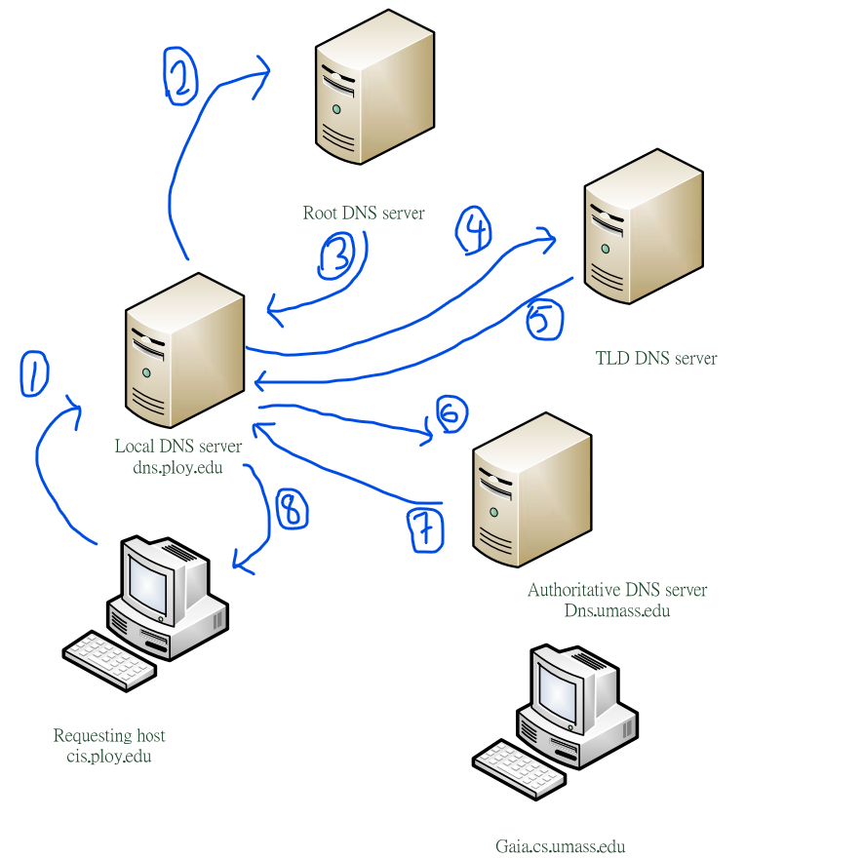

b

By referring to the list of IP addresses found in [Root Servers 2020].

c

To overcome the problem of distance and scale, no single DNS server contains all the mappings for all of the hosts in the Internet. The mappings are distributed in a hierarchical order.

d

The replies are directly returned to the DNS that sent out the query. This approach could potentially save some time, as iteration usually results in a lower time complexity than recursive.

e

One root DNS server contains several TLD servers in a certain region, hence by deducing the possible region of the root DNS, it should probably return the correct IP address to the query sender.

f

DNS cache temporarily stores the DNS replies in the server,and it can cache IP addresses of TLD servers, so that different users who wish to access the site will experience shorter delays, as the DNS server can return the queried IP address stored in cache instead of looking it up again. The caching of TLD servers can also bypass the root DNS servers in the lookup chain, thus saving time.

4.

Facebook(Meta), IP: 157.240.22.35 (IPv4)

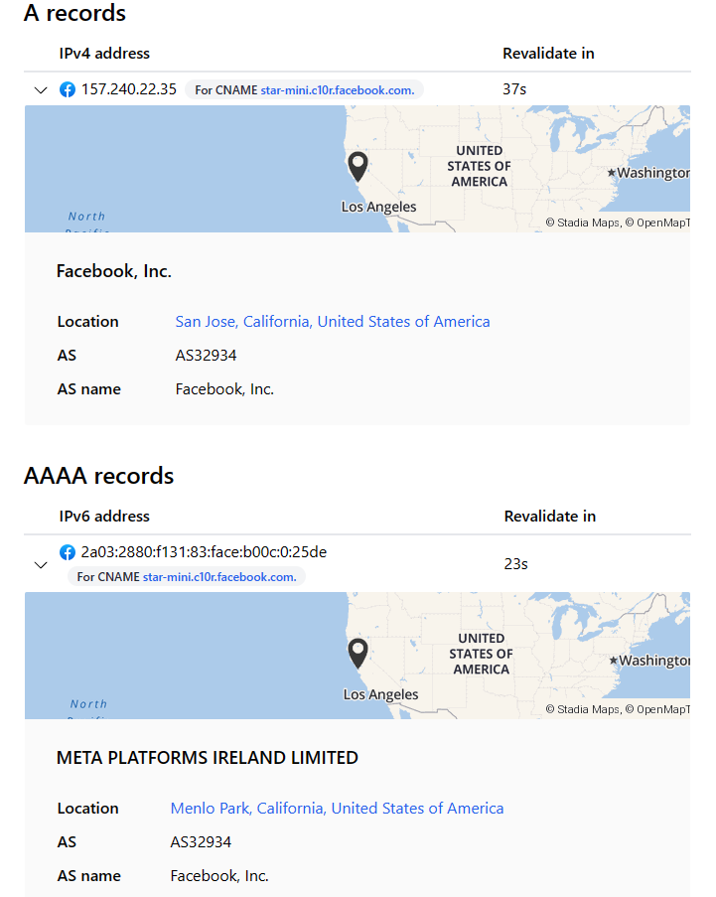

Traceroute Results.

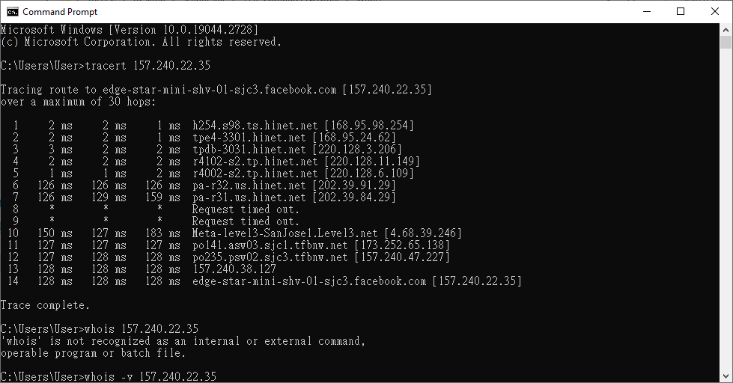

Whois Domain Lookup Result.

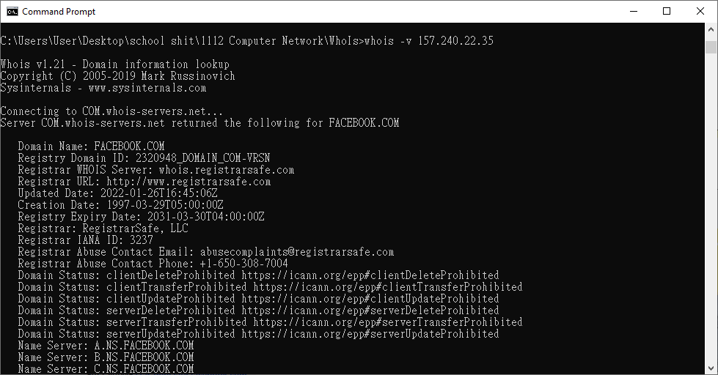

Registrar: RegistrarSafe, LLC.

Google, IP: 172.217.12.100

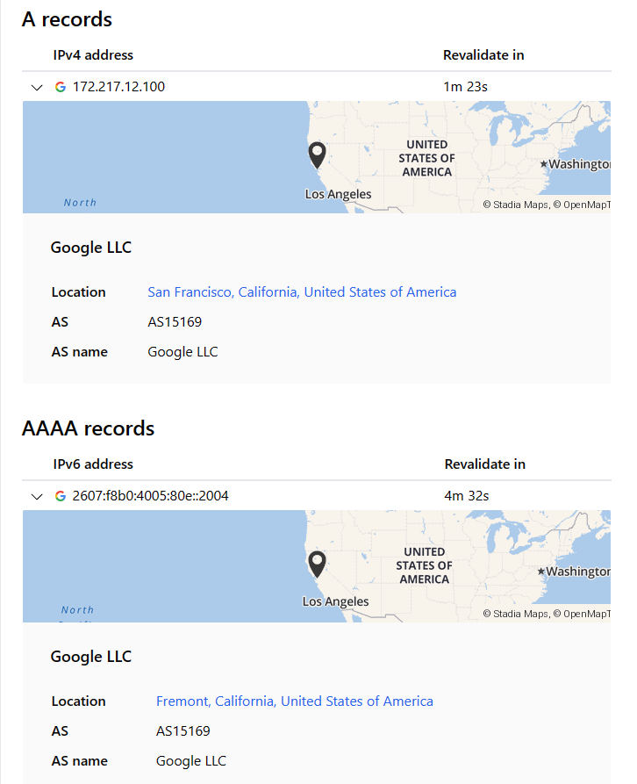

Traceroute Results.

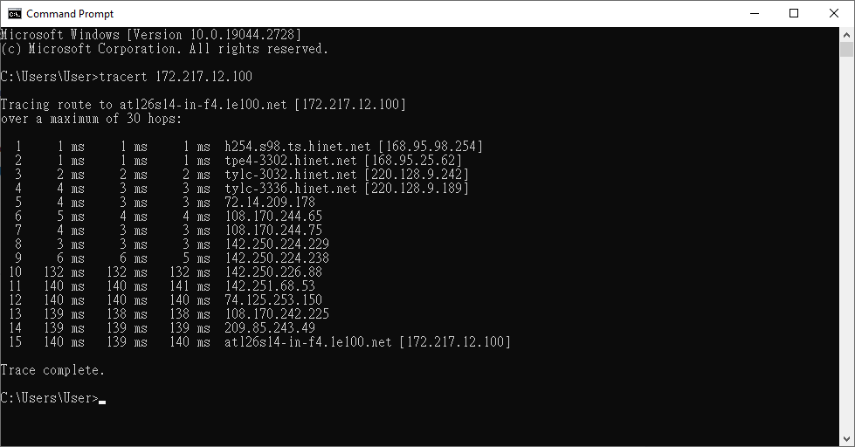

Whois Domain Lookup Results.

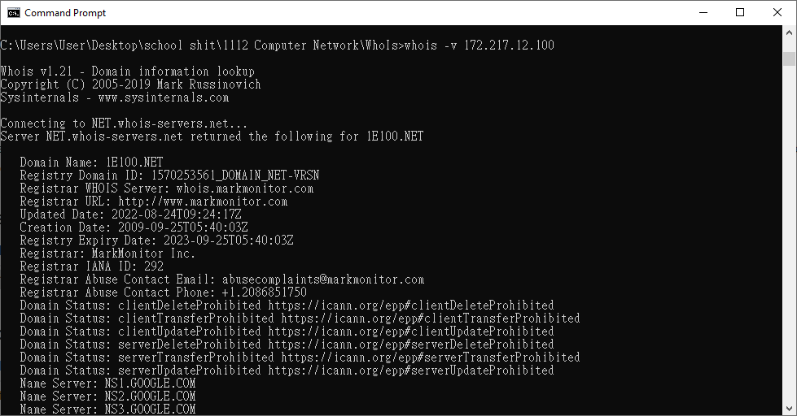

Registrar: MarkMonitor INC.